Will Kelsey, Nick Krysko

APC CURSE

Prof. Carpenter

Sequence Models

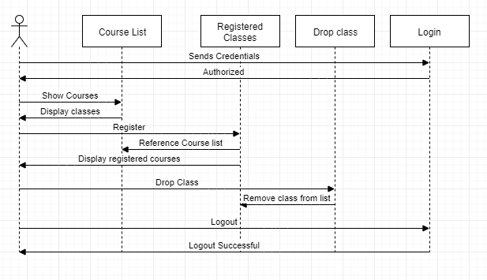When building a program or system, it is good to create a sequence model showing the direction a user could take within. For CURSE, there are three possible users that could interact with the program with each having their own functions and abilities. Shown here is the student sequence. A student logs in using their credentials, and if authorized can continue. The first thing they would want to do is display a list of all available courses. From there, they can register for one of those classes at a time. It is then displayed the currently enrolled classes. Given the need, the student can also drop a class. At any point, any user can logout ending the session.

Admin and instructor work on a similar basis. The instructor can display all the courses they teach. Using that, they can see registered students that are in each class. As of now, the admin can create courses and remove courses. Of course, the course can only be removed if it already exists. Therefore, the removal of a course references the current list of courses to ensure it exists and can be removed.

Further down the road, these models will change with added features and capabilities. These models are in no way complete for the end goal program, however they are enough for basic functionality.